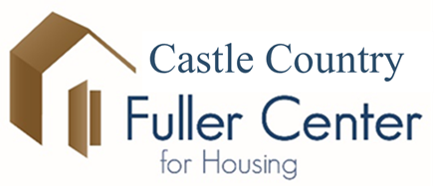
Golf Tournament – Fundraiser

August 20, 2022

Carbon County Country Club
4– Person Scramble
8:30am Shotgun Start
$160.00 / Team, Lunch Included
Green Fees & Cart Separate
To Sign Up, Call (435) 637-2388
Or Visit the Country Club
$100.00 Hole Sponsors - Call (435) 637-9701
375 S Carbon Ave. 435-637-9701

