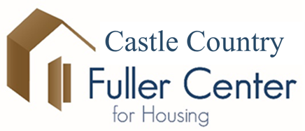
Golf Tournament – Fundraiser
(PLEASE NOTE DATE CHANGE)
AUGUST 20, 2023

Carbon Country Club
4– Person Scramble
8:30am Shotgun Start
$160.00 / Team, Lunch Included
Green Fees & Cart Separate
Hole Sponsorship $100.00
To Sign Up, Call (435) 637-9701
And/or Kathy 636-6898
We are also looking for donations for the raffle and volunteers to help with the tournament.

